Product overview
This portfolio was built as a real product with AI-native processes: a space to clearly communicate my work, thinking, and approach to building with AI.
Detailed below is a workflow across multiple tools which offered full control across design → development → deployment.
No single tool (yet!) offers the speed of GenAI prototyping, pixel-perfect designing of Figma and code quality desired for production. This process ties all of that together.

Tech stack
Workflow diagram shows end-to-end tooling for each stage:
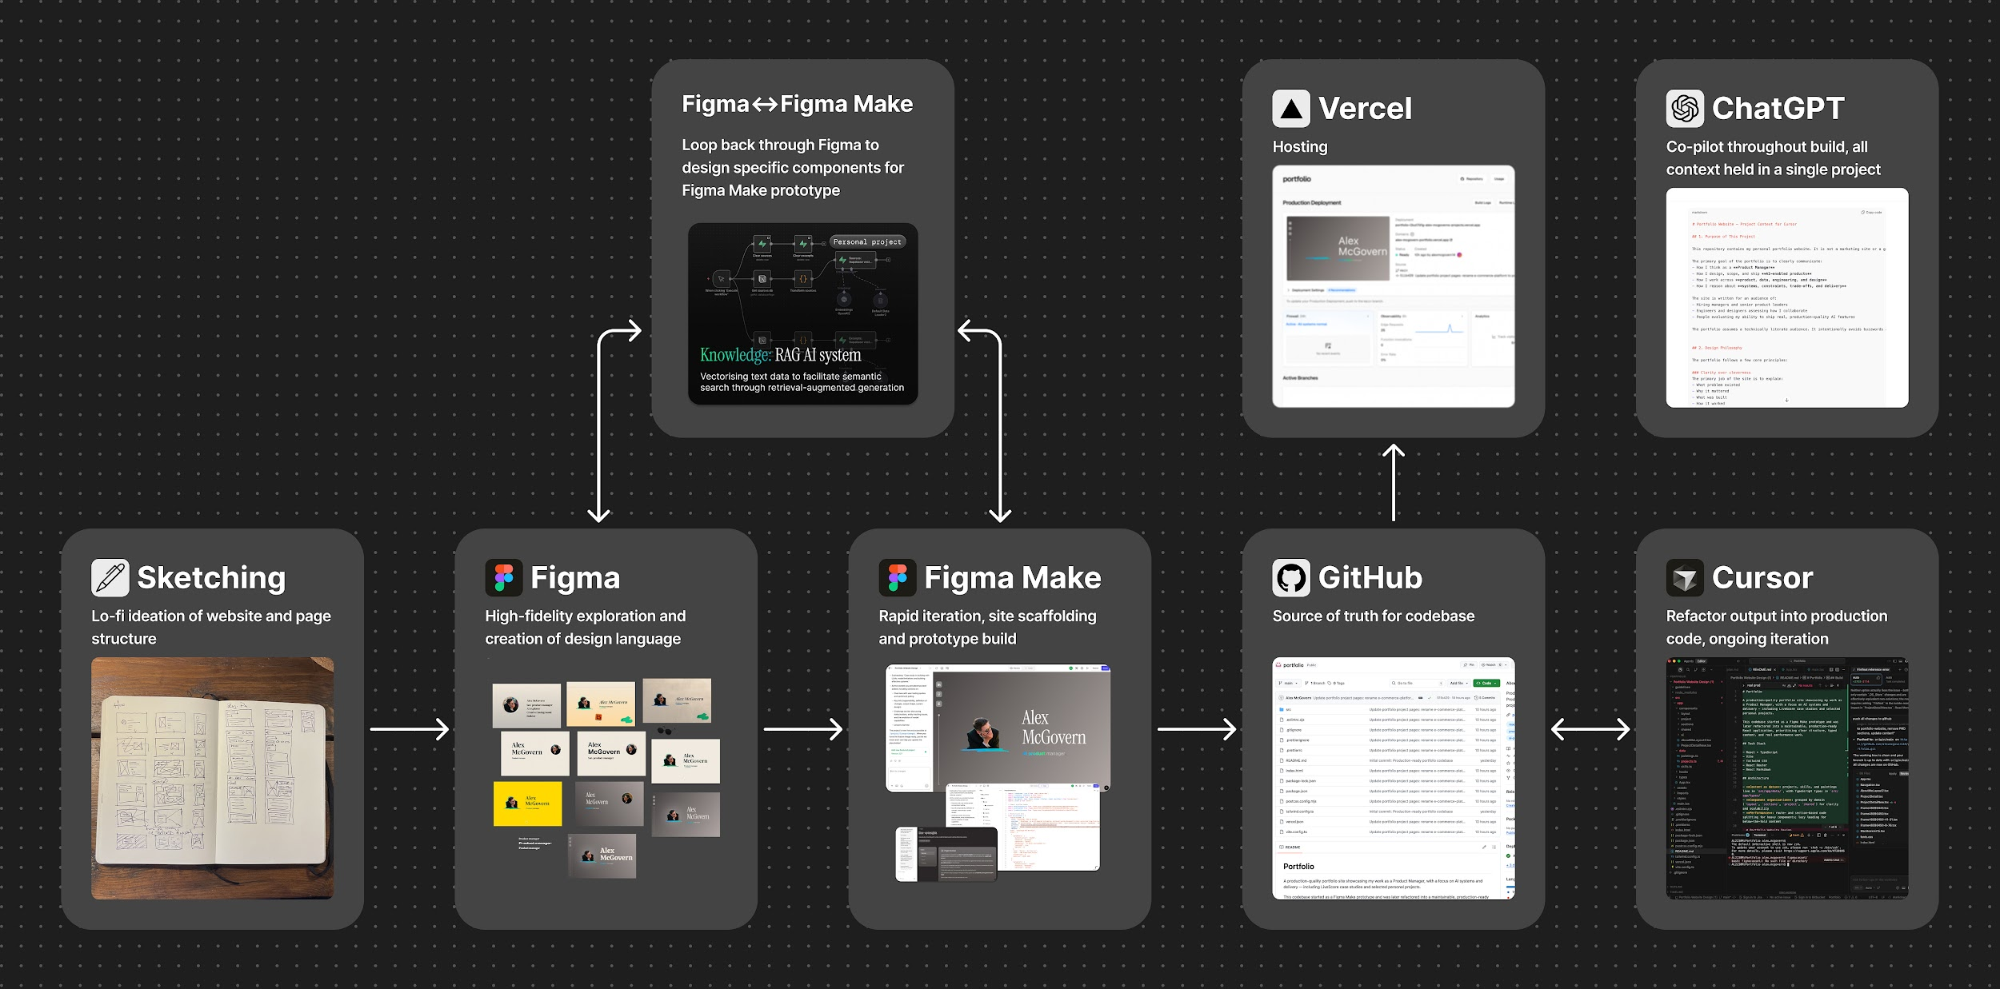

1. ChatGPT
Co-pilot at every stage. A single project (important!) holding all key context and objectives.

2. Sketching
Lo-fi ideation to establish early direction

3. Hi-fi design: Figma ↔ Figma Make loop

3.1 UI design: Figma
High-fidelity design exploration; building towards a consistent visual language across colour schemes, page design, core components and key pages.

3.2 Prototyping: Figma Make
Chosen on this project over Lovable and others for integration with Figma. Designs were converted to a working prototype, which was used for rapid iteration: testing ideas and design treatments, site scaffolding, building out lower-priority components quickly and testing user journeys.
This stage produced a fully working prototype, site scaffolding, and surfaced design and structural issues.

3.3 Figma ↔ Figma Make loop
During prototyping there are many cases where prompting will not accurately build particular components as desired, especially when the vision is not clear, and diving back into pixels is a faster and more precise way of achieving design solution.
Specific components were therefore designed directly in Figma and fed back into Figma Make prototype mid-build — this is very powerful and solves, in my view, the biggest issue of GenAI prototyping. It combines the speed and scale of generative prototyping with the precision of manual, pixel-perfect design.
Output: Fully working, pixel-perfect prototype. A real product with code which is pushed to…

4. GitHub
Source of truth for codebase

5. Cursor
Prototype codebase pulled into Cursor to refactor generated output into production-quality code that can be owned, properly structured, trusted and iterated.
A few refactoring examples:
- Separation of concerns: Large components broken down into focused, single-purpose components
- Structured codebase: easier to navigate and safely make changes to
- Systematic styling and layout: consolidated so that spacing, colour, and typography were applied consistently.
- Optimised loading behaviour
- Accessibility
- SEO metadata, site map etc.

5. Vercel
Free hosting!

Combining the tools in this workflow facilitates rapid prototyping (Figma Make), detailed UI design (Figma) and production code quality.

